

Department of Computer Science & Information Technology

III Year,V Semester(Batch 2022-2026)
Lab Record Submission of

Linux (Lab)
Subject Code – CSIT-505

Submitted to: Submitted by:
Prof. Nidhi Nigam Tanishka soni
0827CI221135

Linux Lab file -2

Commands
- Man command
Syntax- man (common name)
Description- This is the command itself, which invokes the manual page viewer.
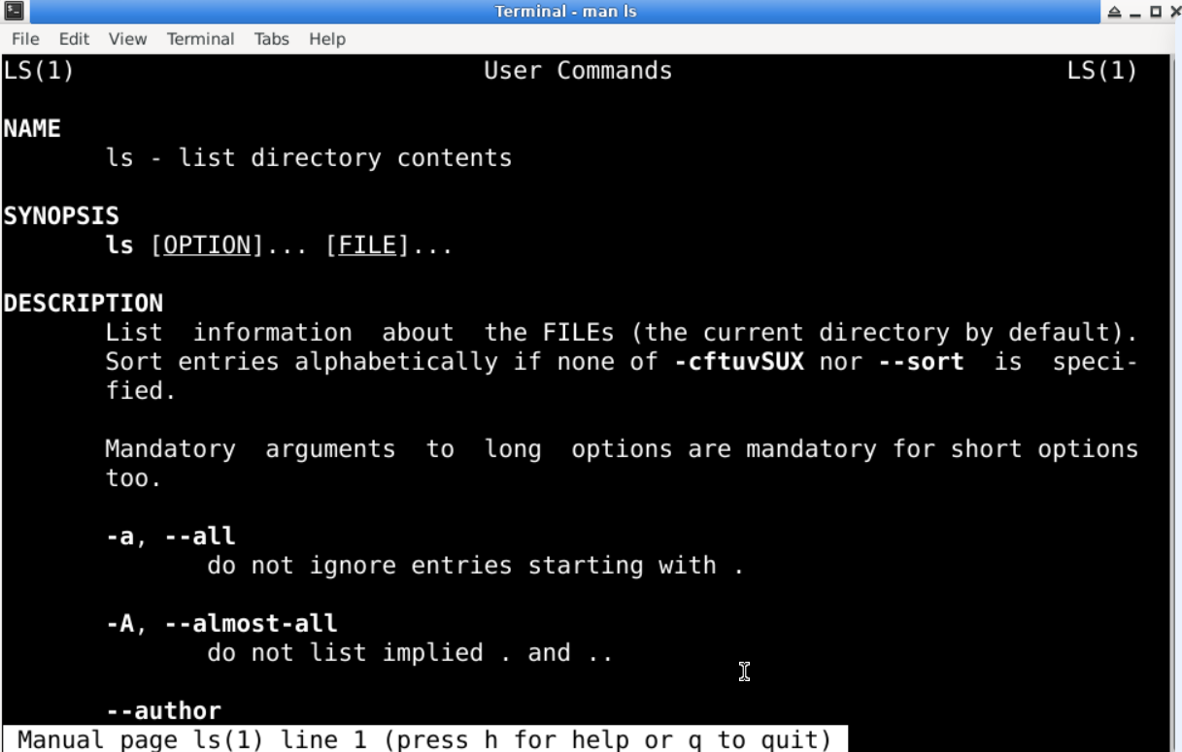

- echo command
Syntax- echo(statement)
Description: This is a built-in command in many shell environments, including Bash. Its primary function is to display a line of text or a variable value to the standard output (usually the terminal).

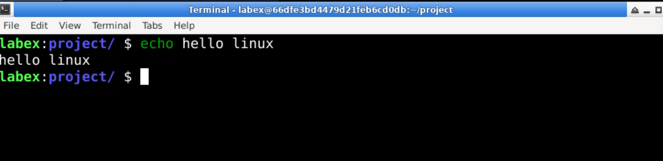

- whatis command
Syntax- whatis(command name)
Description- : This is the command itself, which queries the manual database for descriptions of commands.
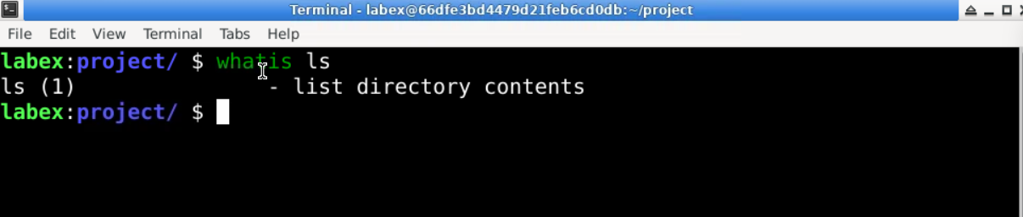

- date command
Syntax- date(command name)
Description- : This is the command itself, which retrieves and displays the current date and time.
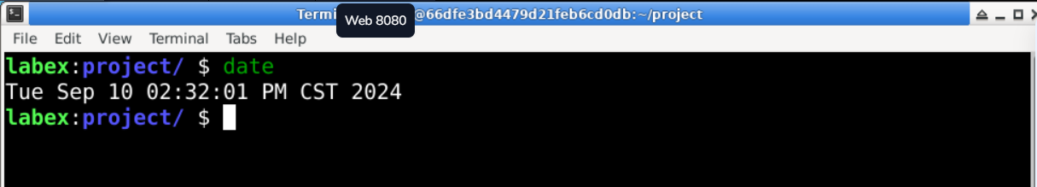
- pwd command
Syntax- pwd
Description- : This is the command itself, which outputs the full path of the current workingdirectory. 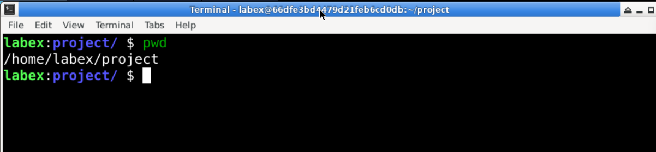

- mkdir command
Syntax- mkdir (directory name)
Description- : This is the command itself, which is used to create one or more directories.

- cd command
Syntax- cd (directory name)
Description- : This is the command itself, which is used to change the current working directory.
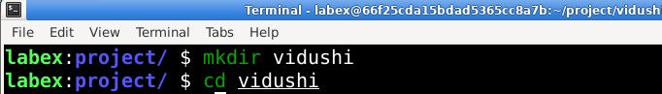
- rmdir command
Syntax- rmdir (directory name)
Description- : This is the command itself, which is used to remove empty directories.
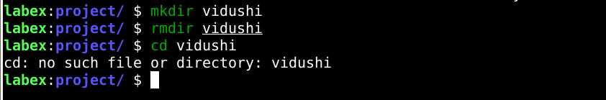
- ls command
Syntax- ls
Description- This is the command itself, which stands for "list." By default, it lists the files and directories in the current working directory.
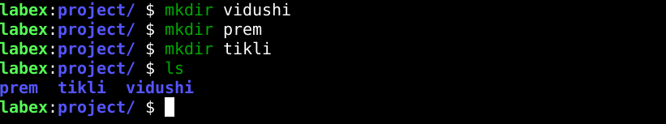

- grep command
Syntax- grep(file name)
Description- This is the command itself, which searches for patterns in text.
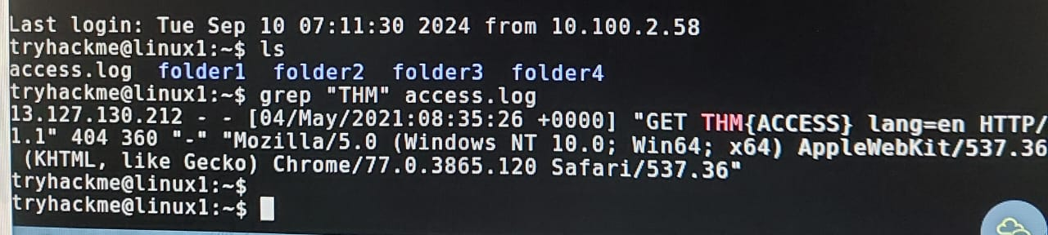

- find command
Syntax- find(file name)
Description- The find command is a powerful utility in Unix/Linux systems used to search for files and directories within a specified directory hierarchy
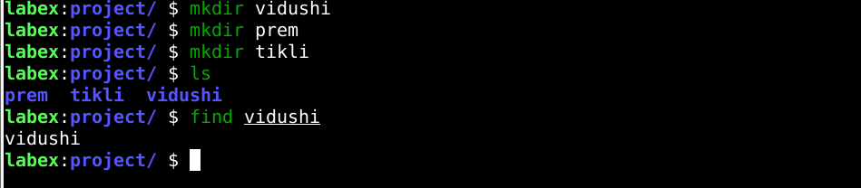

- touch command
Syntax- touch(file name)
Description- The touch command in Linux is used to create empty files or update the timestamps of existing files
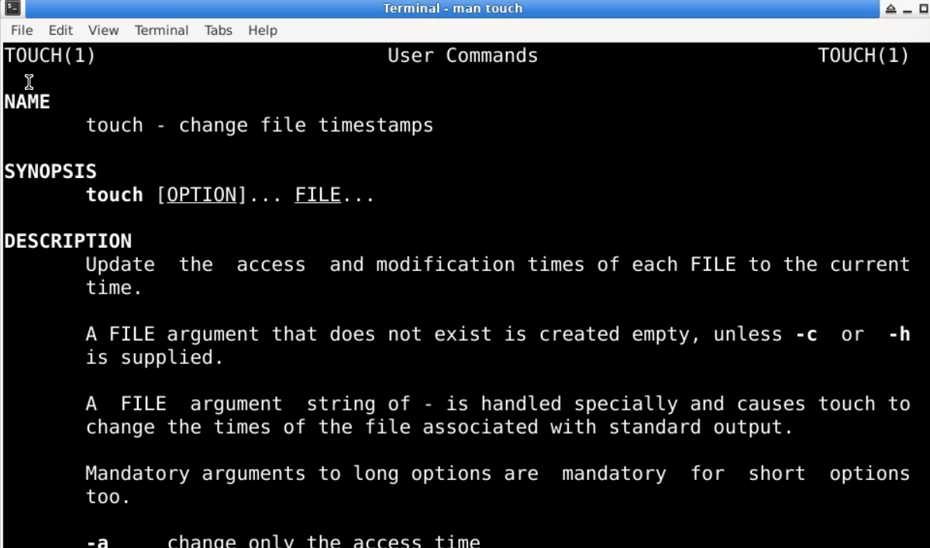

- ls -l command
Syntax- ls -l
Description- The ls -l command in Linux is used to list files and directories in a detailed (long) format.
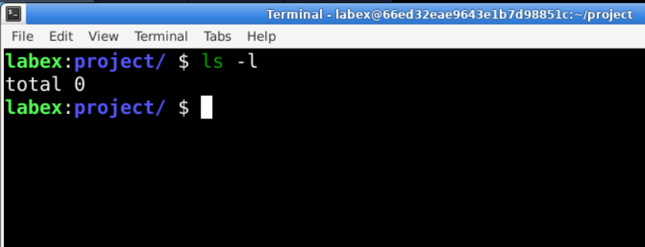
- cp command
Syntax- cp [options] source destination
Description- The cp command is a utility in Unix-like operating systems used to copy files and directories.
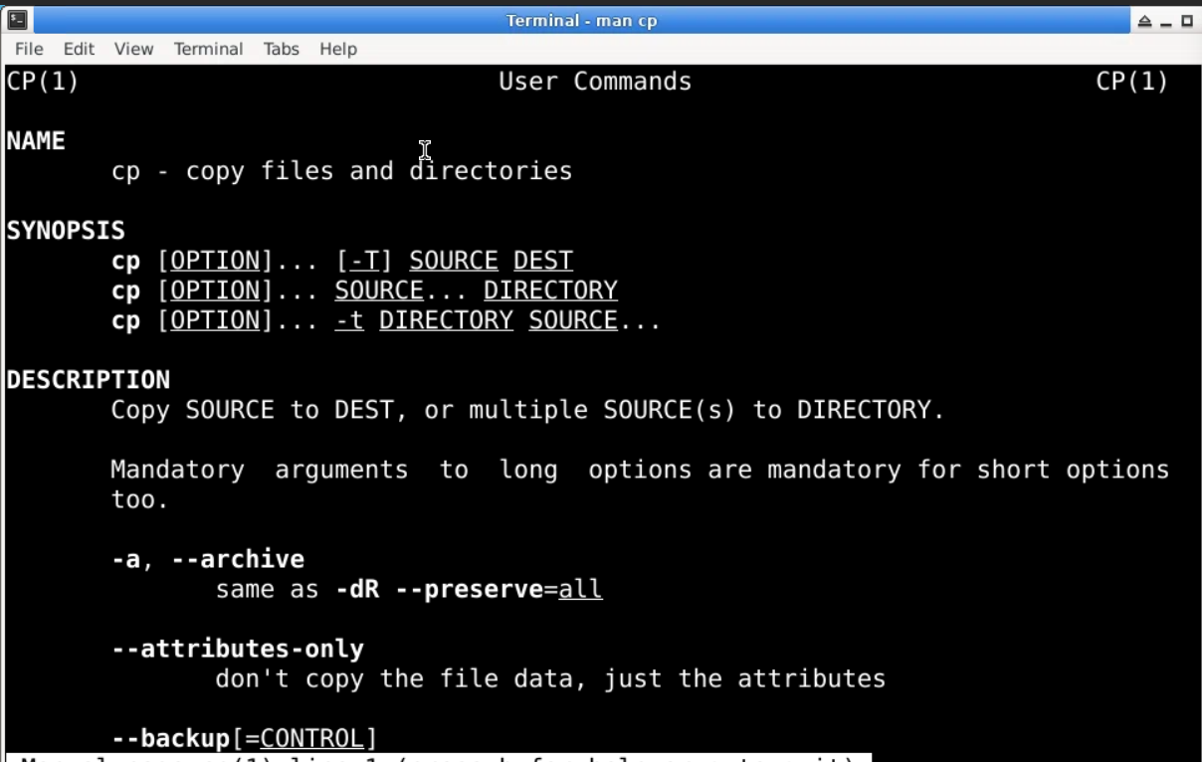

- ls -a command
Syntax – ls -a
Description - The ls -a command in Linux is used to list all files and directories in the current directory, including hidden files.
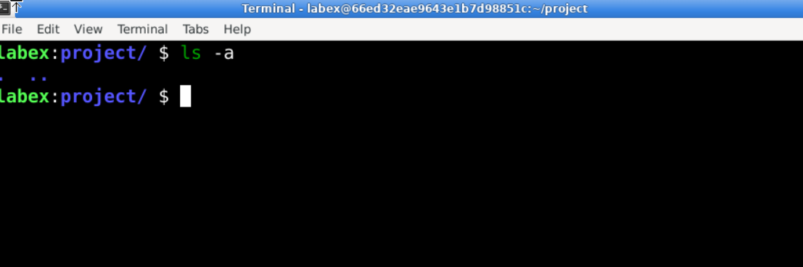

- mv command
Syntax- mv (file name)
Description- The mv command in Linux is used to move or rename files and direc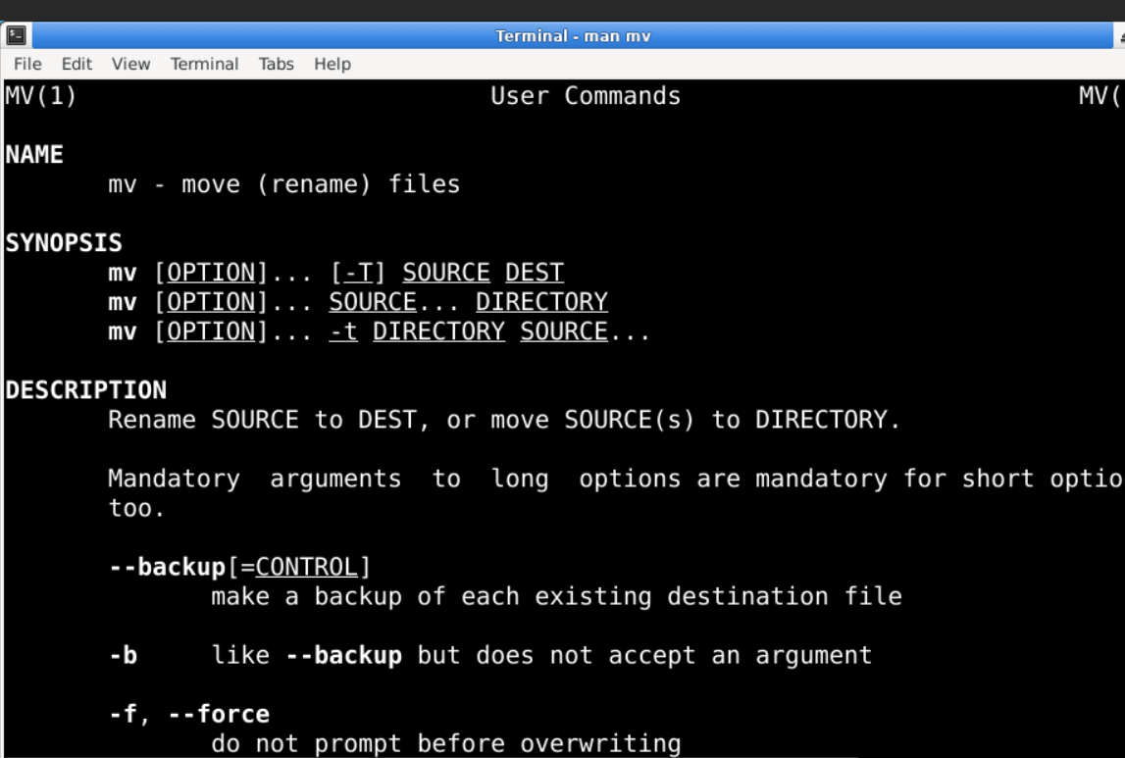

- less command
Syntax- less (file name)
Description- The less command is a commonly used command-line utility in Unix-like operating systems for viewing the contents of files one screen at a time

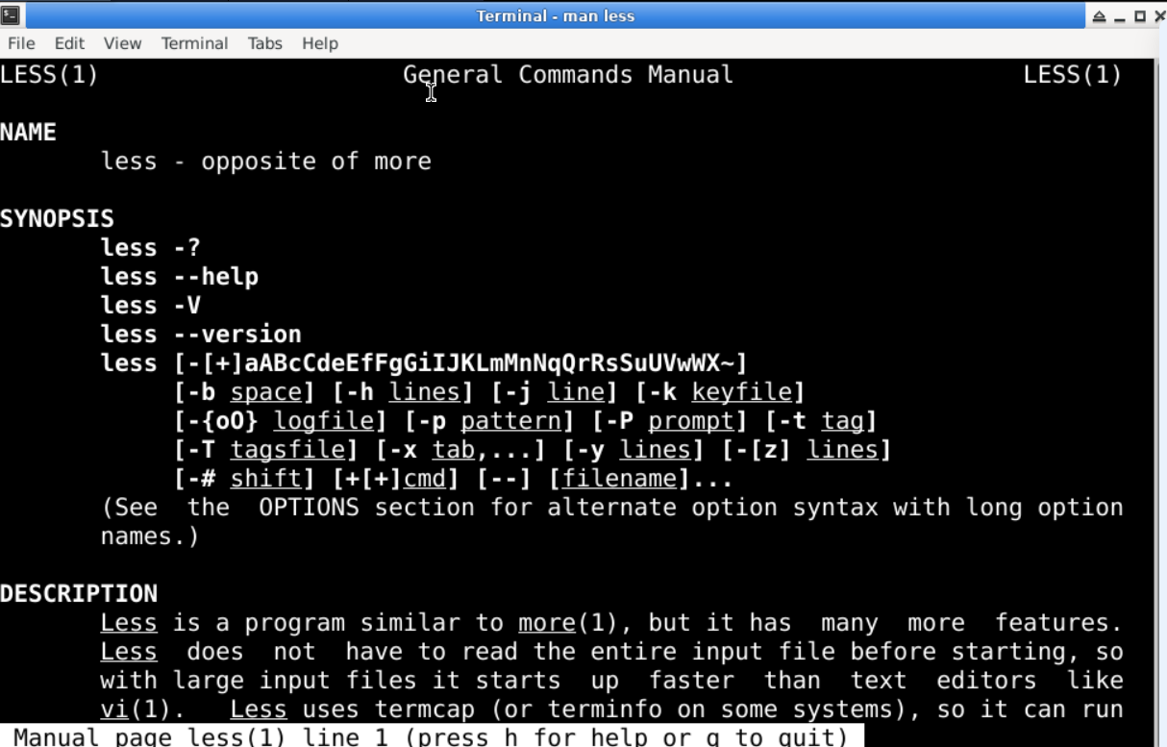

- ps command
syntax- ps
description- The ps command is used in Unix-like operating systems to display information about the currently running processes.
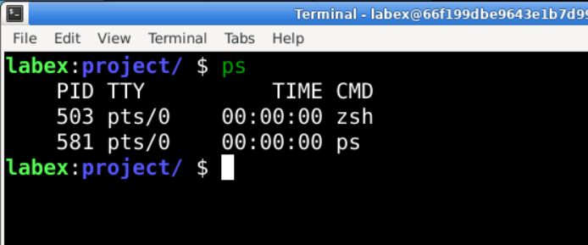

- kill command
syntax- kill [optin] <pid>
description- The kill command is used in Unix-like operating systems to terminate processes
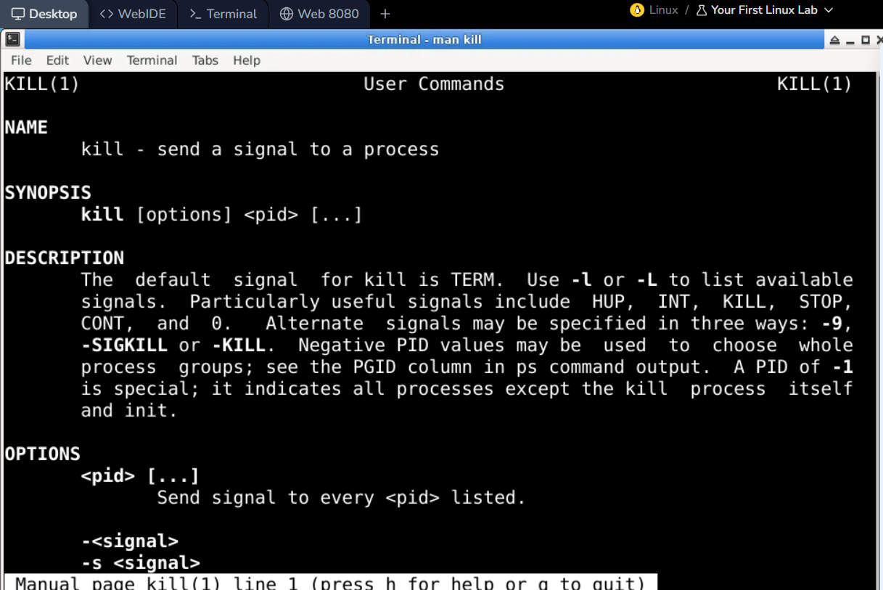
- ip
syntax-ip
description- The ip command is a powerful utility in Linux and Unix-like operating systems used for managing network interfaces,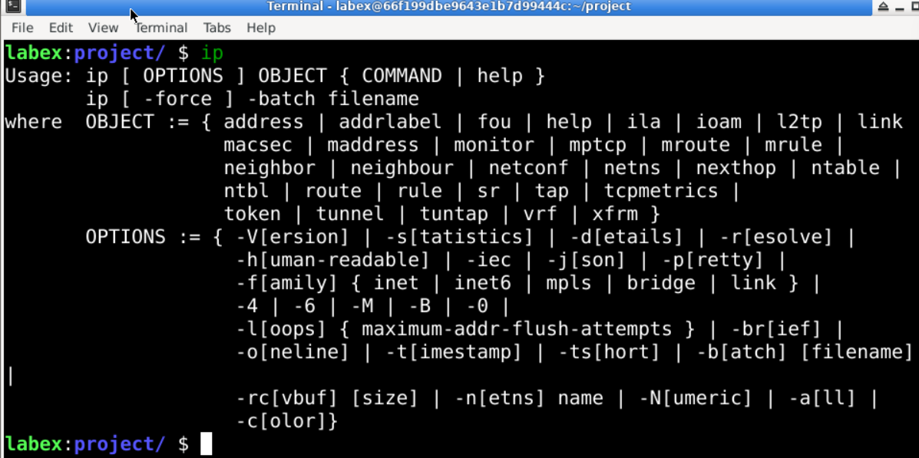

- ifconfig command
syntax= ifconfig
description- The ifconfig command is a network utility in Unix-like operating systems used to configure and display network interface parameters.
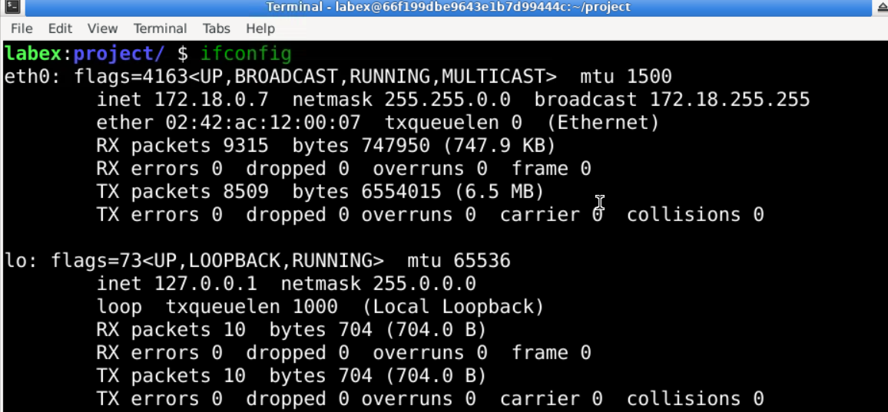

- head command
syntax- head (file name)
decription= The head command is a utility in Unix-like operating systems used to display the beginning of a file or standard input.

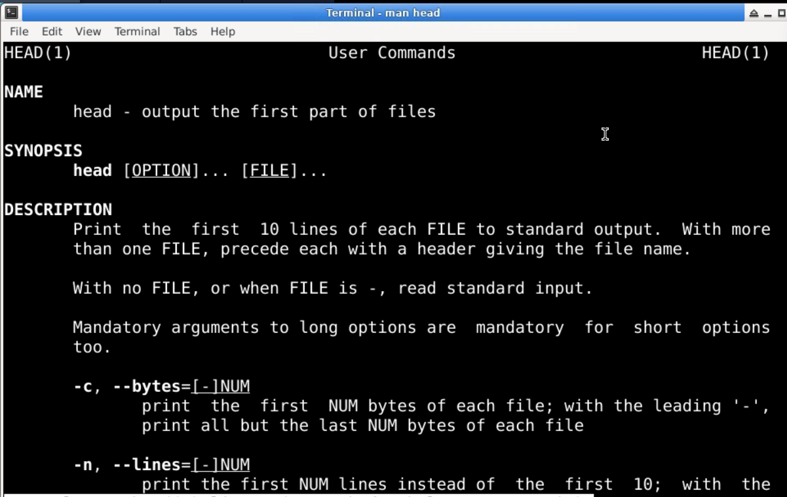

- tail command
syntax- tail (filename)
description- The tail command is a utility in Unix-like operating systems used to display the end of a file or standard input
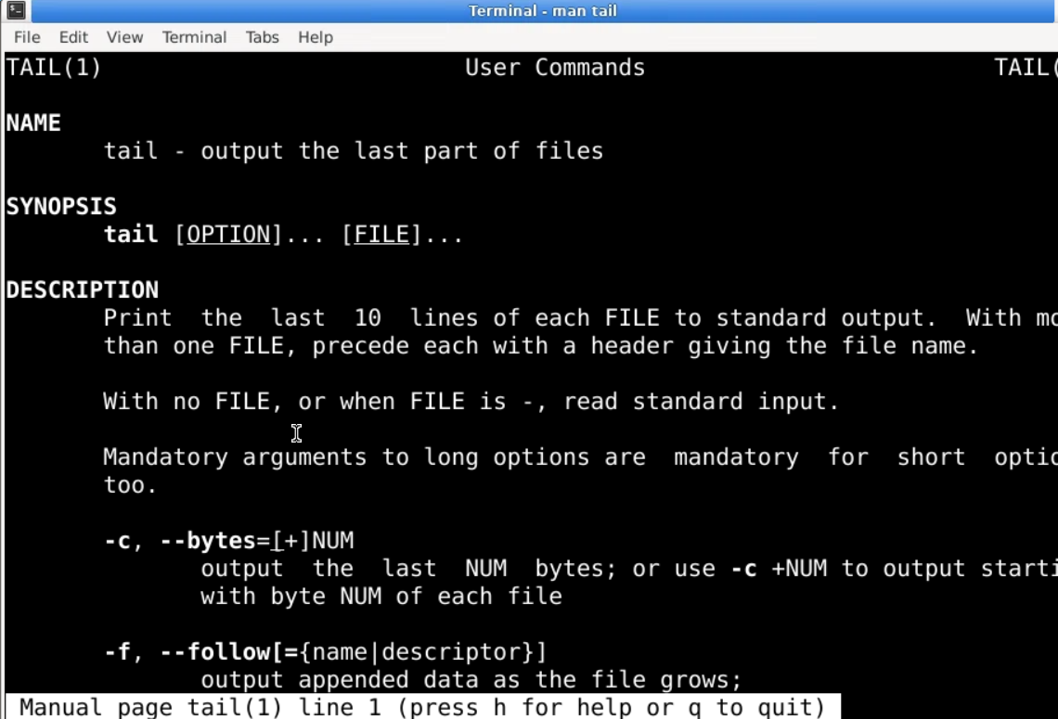

THANK YOU!!

